**What is Cloud Computing?**

The term "**Cloud Computing**" generally refers to the ability of a system to store data or applications on remote servers, process data or applications from servers, and access data and applications via the Internet. Cloud computing provides scalability, flexibility, cost-effectiveness, and security to individuals and organizations to manage their IT operations. Cloud computing works on a Pay-on-Use basis for individuals and organizations. It is an on-demand availability of system resources and computing power without direct active management by the user.

**Examples of Cloud Computing**

Cloud computing is the ability to deliver computing services, such as servers, storage, database, networking, and intelligence. Here are some examples of Cloud Computing:

* **Cloud-based virtual desktops:** These help users access their systems and applications by using any device from anywhere. Examples of Cloud-based virtual desktop providers are Amazon WorkSpace, VM ware, Horizon Cloud, and Virtual Windows of Microsoft.
* **Cloud Backup and Cloud Storage:** Cloud storage generally provides safe and scalable storage options for organizations and individuals to store and Cloud backup provides backup for the data.
* **Cloud disaster recovery:** This service users to have a backup of their data when any disaster recovery needs to occur. Some Examples of Cloud disaster recovery include Mozy, Amazon Glacier, and Carbonite.
* **Infrastructure-as-a-Service(IaaS):** It helps businesses to scale their computer resources up or down whenever needed without any requirement for capital expenditure on physical infrastructure. Examples of IaaS providers are Amazon Web Service(AWS), Google Cloud, and Microsoft Azure.
* **Software-as-a-Service(SaaS):** With the help of SaaS, users can able to access applications hosted in the cloud, rather than installing and running them on their local devices. Examples of SaaS applications are Salesforce, Dropbox, and Microsoft Office 365.
* **Platform-as-a-Service(PaaS):**This helps organizations with a cloud-based platform to build, deploy, and manage applications. Examples of PaaS providers are Google App Engine, Microsoft Azure, etc.

**Cloud Computing Architecture**

Cloud computing architecture refers to the components and sub-components required for cloud computing. These components typically refer to:

1. Front end ( Fat client, Thin client)
2. Back-end platforms ( Servers, Storage )
3. Cloud-based delivery and a network ( Internet, Intranet, Intercloud )

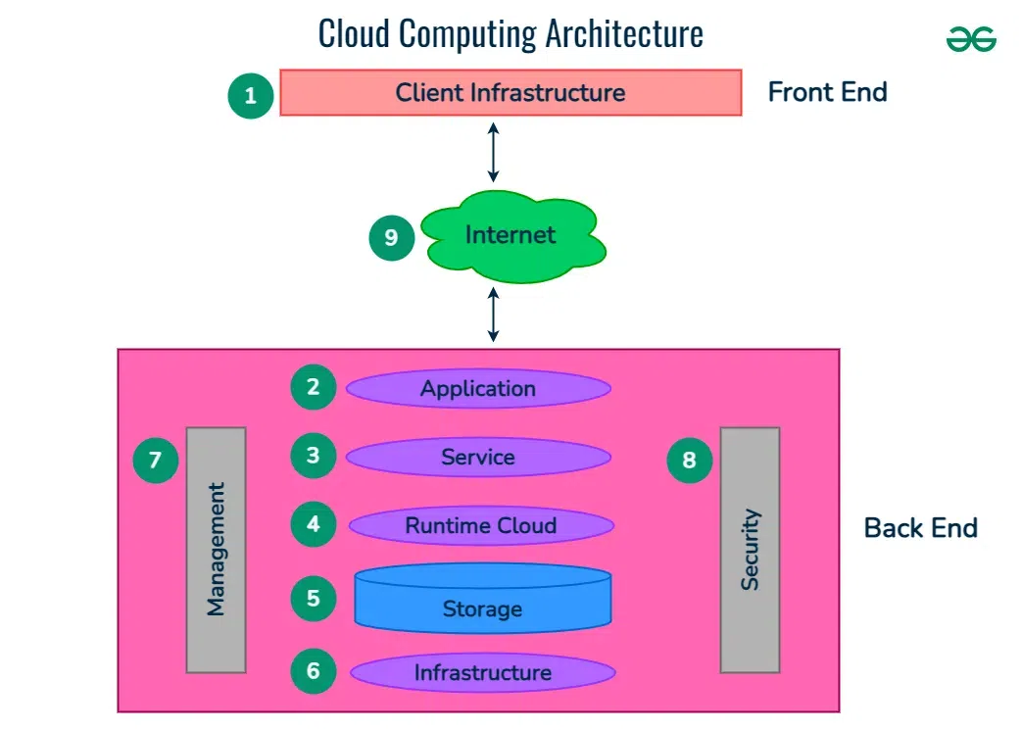

**1. Front End ( User Interaction Enhancement )**

The User Interface of Cloud Computing consists of 2 sections of clients. The Thin clients are the ones that use web browsers facilitating portable and lightweight accessibilities and others are known as Fat Clients that use many functionalities for offering a strong user experience.

**2. Back-end Platforms ( Cloud Computing Engine )**

The core of cloud computing is made at back-end platforms with several servers for storage and processing computing. Management of Applications logic is managed through servers and effective data handling is provided by storage. The combination of these platforms at the backend offers the processing power, and capacity to manage and store data behind the cloud.

**3. Cloud-Based Delivery and Network**

On-demand access to the computer and resources is provided over the Internet, Intranet, and Intercloud. The Internet comes with global accessibility, the[Intranet](https://www.geeksforgeeks.org/what-is-intranet/)helps in internal communications of the services within the organization and the [Intercloud](https://www.geeksforgeeks.org/inter-cloud-resource-management/) enables interoperability across various cloud services. This dynamic network connectivity ensures an essential component of cloud computing architecture on guaranteeing easy access and data transfer.

**Why Cloud Computing?**

* **Scalability**: Cloud computing services enable organizations to effortlessly scale up or down their computer capacity to suit changing demands. The flexibility is especially advantageous for organizations with varying workloads or seasonal demand since it helps them to avoid the cost of maintaining superfluous infrastructure.
* **Accessibility**: Cloud Service can be accessed from anywhere. It provides the ability for remote workers they can collaborate and access the same resources as their in-organization colleagues.
* **Security**: Another amazing characteristic of cloud computing is that it is highly secure. Cloud computing provides robust security measures to protect their client's data from unauthorized users or access.
* **Cost-Effectiveness**: Another benefit of using cloud computing is that it is cost-effective and Cloud services are generally priced on a pay-per-user basis which means organizations have to pay when they use the service.